PAPER TITLE (12 pt, bold, Times New Roman)

Author 1, Author 2,… (10 pt)
Name and address of insitution, e-mail (9 pt)

Keywords: (10 pt, Bold)

ABSTRACT: (10 pt, Bold, Italic)

Abstract text has to be written by Times New Roman, italic font, 9 pt. The paper should be written on A4 format in Microsoft Word, and the paper margins are: left and right 4 cm, top and bottom 4,6 cm.Header and footer are to be set on 4,6 cm from the top and bottom of paper.

1. INTRODUCTION (10 pt, Bold)

The chapter titles have to be written with capital letters font 10 pt. bold. The chapters are numbered as above shown. The chapter text has to be written by Times New Roman font, 9 pt. The distance between text and title is one line of 9 pt font.

2. OTHER CHAPTERS (10 pt, Bold)

Paper text has to be written in Times New Roman font 9 pt. The chapter titles have to be written with capital letters, Times New Roman font 10 pt bold. Number of pages is limited to 4 or 6 pages. We kindly ask You to keep page limit, in other case we will have to return Your paper.
If the chapter has its parts then they have to be written as shown.

2.1. Chapter part title (10 pt, Bold)

The figures in the paper have to be centered in the middle of the page. If there is any text on the figure then is font text Times New Roman 9 pt Italic. The figures are numbered and the Figure title has to be written below the figure in the page middle as shown in example.
If there are any tables in the paper then is text in the table also Times New Roman font 9 pt. Tables also have to be numbered and the table title is to be written before the table as shown in the example.

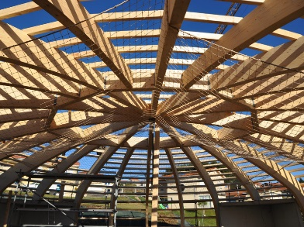

Figure 1: Figure title (9 pt Italic)

Table 1: Table title (9 pt)

Big products | Middle products | Ssmall products
to 5 | to 20 | to 100
5 – 100 | 20 – 200 | 100 - 500
- | 200 – 500 | 500 - 5000

If there are any equations in the paper then they are to be written in the middle of the page and to be numbered as shown in example. Equation font is Times New Roman, 9 pt, italic.

$x_{1,2}=\frac{-b±\sqrt{b^{2}-4ac}}{2a}$ (1)

3. CONCLUSION (10 pt, Bold)

We kindly ask You to write Your paper according to this instructions. In other case we will return Your paper for correction.
Final paper is to be send until July 5th 2019 in electronic form on e-mail: tfb.rim@gmail.com.

Official languages of the Conference are Bosnian and English.
The conference fee is 100 Euro (single oral presentation) and 90 Euro (poster presentation).
The conference fee for students is 25 Euro.

4. REFERENCES (10 pt, Bold)

[1] Hrnjica, B., Danandeh Mehr, A. (2019). Optimized Genetic Programming Applications: Emerging Research and Opportunities. Hershey, PA: IGI Global. doi:10.4018/978-1-5225-6005-0
[2] Crnkić, A., Jaćimović, V. (2018). Data clustering based on quantum synchronization. Natural Computing, 1–5. https://doi.org/10.1007/s11047-018-9720-z
[3]

